PROG 02-C Submission

Youtube Link: https://youtu.be/apLhIkK1Uo4
Github Link: https://github.com/cs160-sp16/prog-02-represent-sandsub95

Explanation of Changes from Before:

Change #1:

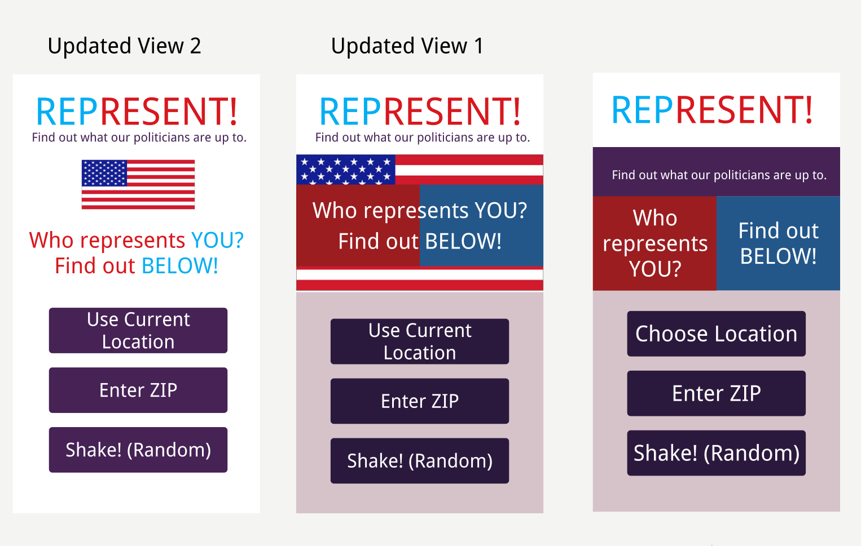

The rightmost image shows my original rendering of the main view, but the feedback I received was that it seemed like the “Who represents YOU?” and “Find out BELOW!” elements could be mistaken for buttons, so in the second iteration I wrote the text across the two elements and moved the app’s purpose statement to underneath the title, but after that, I thought I could simplify the color scheme a little more and remove some of the three purples and just bring it to one, so that’s what I did.

Change #2: (Before on Top, After on Bottom)

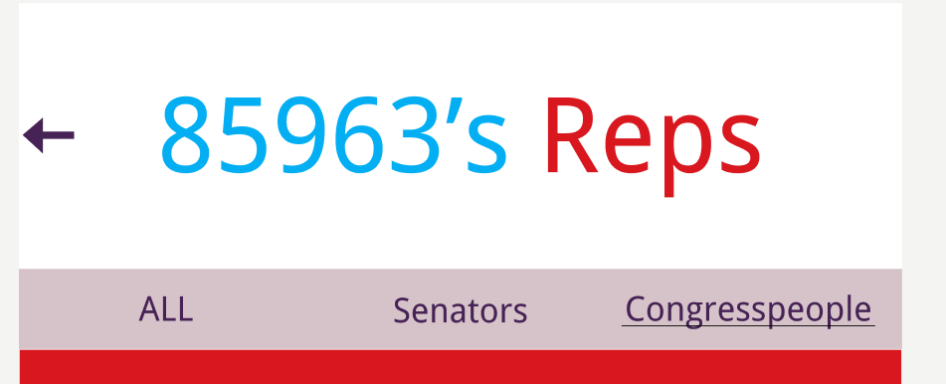

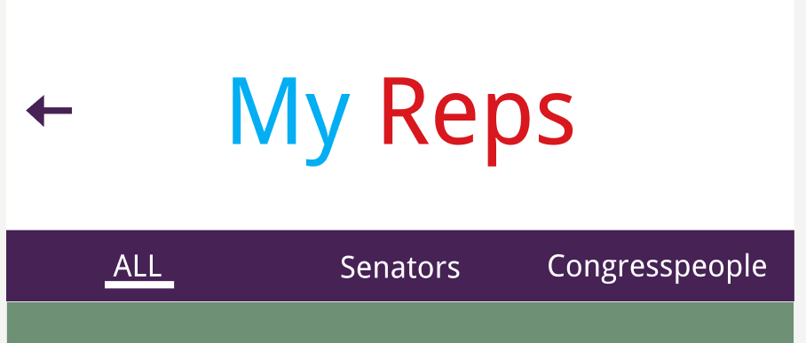

I received feedback that the underlining was not clear in my intended menu, so in accordance with my color simplification scheme described before, I changed the menu to a darker color so that each menu option would stand out more, and I made the underlining a very clear and solid rectangle so that people could see the different options. I also added a green color for independent senators and representatives, a color that was not present before.

Change #3: (Before on Left, After in Middle, Actual Appearance on Right)

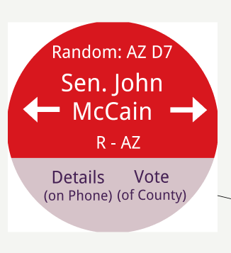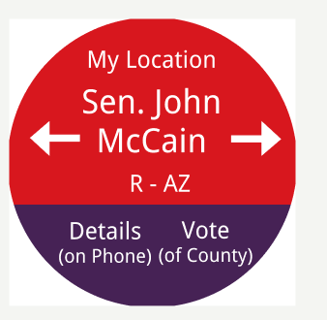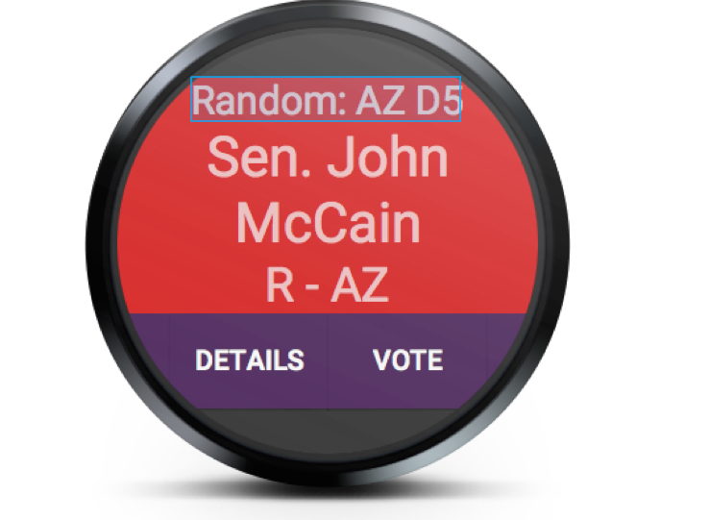

Here, also, I simplified the purple coloring to make the options clearer.

Change #4: (Before on Top, After on Bottom)

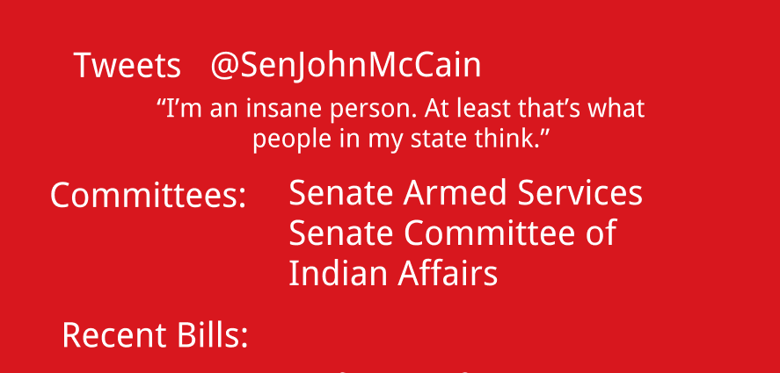
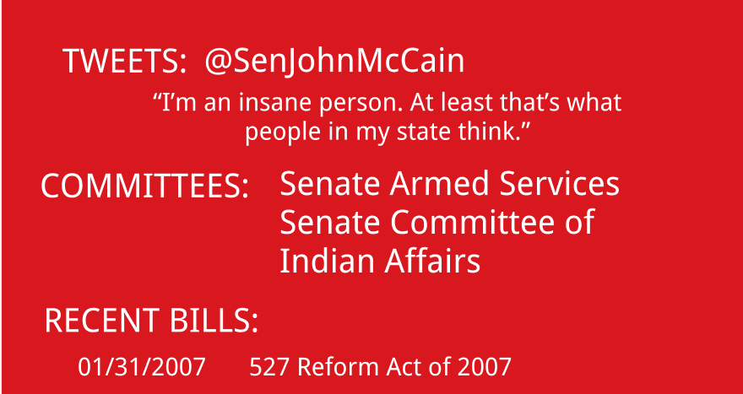

Here, I was given the comment that the section titles blended into the content too much, so I capitalized them to give them better emphasis, and I changed some of the font sizes of the actual material. This allows it to stand out as a title a little more, though I could have perhaps used letter-spacing and other such techniques to improve it.

